Drax Dome Rotator Controller

Overview
This is an ASCOM compliant device that will rotate the Drax dome when commanded to do so via tracking software on a PC. The electronics is based around an Arduino Nano microcontroller connected to a PC via a USB cable, a cable and position sensor, a cable and reed switch (for detecting the home position), some status LEDs and a buzzer. The Software is in three parts: the ASCOM drivers that run on the PC, the code programmed into the Arduino and a PC application that will calibrate the controller. Mechanically there are various plastic housings (3D printed) and metal brackets to hold the housings. A magnet is mounted on the fiberglass of the dome to indicate the Home position. Two outputs are provided to control the rotation motor via the inverter.

Electronics
Power is provided by the USB (5V) at around 350mA peak.
The main circuit board is electrically isolated from the power electrics (to minimise lightning strike damage) by providing outputs to opto-couplers controlling the drive motor inverter

LEDs
These will illuminate (one at a time) on power up (self-check) and then reflect the status of the controller.
Ready (green): If all self-checks are passed OK then this illuminates to say the controller is ready to receive a new ASCOM command (or a calibration command).
CW (yellow): illuminates when the controller has commanded the invert to rotate the dome Clockwise.
CCW (yellow): as for CW but Counter-clockwise.
ERROR (red): illuminates whenever an error state is encountered (things taking too long, calibration failure etc.).
Park (green): illuminated when the controller senses the park magnet has switched the reed switch.

Buzzer
This is to warn that the Dome is about to rotate. It sounds when power is first applied, when ASCOM initially takes control and when it is commanded to rotate.
and a magnetic reed switch to detect when the Dome is in the Home position. The control of the inverter (that drives the rotation motor) is via two logic level outputs.

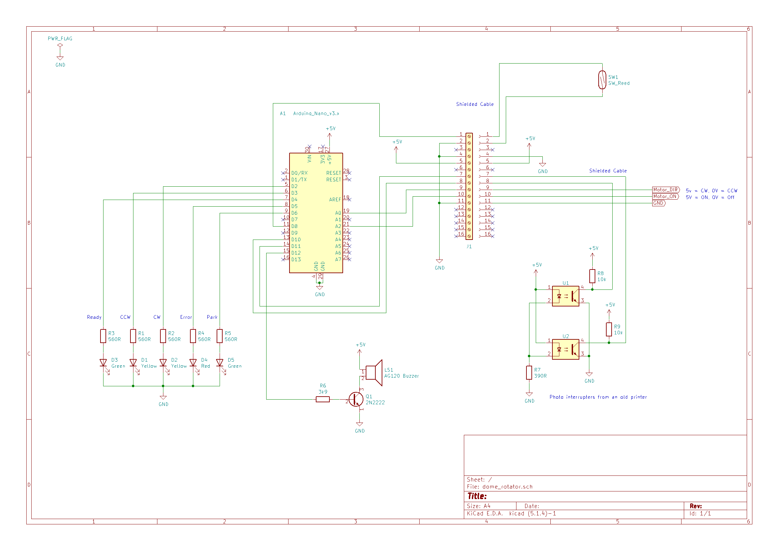Drax Dome Rotator Schematic

3D Printed Plastics
These Items are all produced in FreeCAD 0.18.

Position sensor housing
This is in two parts, the top cover and a base that screws onto the metalwork of the motor support.
Things to note: the housing is not symmetrical. When printed the cable outlet is only made with a pilot hole and needs drilled to the correct diameter for the cable in use (5mm in the original).
Two parts of the photo interrupter sensor housing

Reed Switch Housing
This housing screws to the vertical arm that positions it close to the dome fibreglass.
The Reed switch housing

Hardware
The main circuit board in housed in a DIN rail holder mounted in the motor housing.

Sensor Wheel
This is in 2 parts, a metal collar that mounts onto the axle of the motor drive and a milled CD that acts as a position sensor for the phot-interrupters in the sensor housing. The metal collar also acts as an end float stop on the motor drive shaft. The wheel was created on a milling machine with a 10mm milling cutter.

Reed switch support
This is a simple metal bracket that supports the plastic reed switch housing so that the magnet (mounted on the fibreglass) can switch the reed switch when it is in range.

Software

Arduino Nano Software
This supports the normal “slew to bearing” ASCOM commands and the “home” command. It does not support park (as we cannot differentiate park and home in the observatory). It communicates using USB acting as a COM (serial) port.
The code was developed in Arduino IDE 1.6.7
All code documentation is in the code itself. However, briefly, the code consists of a setup function that is called once before anything else is called, that initialises all the hardware; and a loop function that is called repeatedly once the setup has finished. This loop checks for new commands from the serial port and also maintains a state machine for processing commands that have already been received.
The code is in the file Drax_Dome_Rotator.ino
On power up the code will check to see if it has been calibrated or not. If it has then an initialisation state is set up which contains another state machine that will initialise the dome. If there is no calibration then it will go into an error state and await calibration.
Initialisation ensures that the dome is in a known position. This is achieved by rotating the dome out of the home position and then rotating it back into the home position from thus ensuring an accurate reading of the magnet home sensor.
The calibration is stored in EEPROM and executed via a PC application.
Control of the status LEDs, and the Buzzer are all handled from the Arduino Nano.

ASCOM Driver

Calibration
There is an application to run on the PC to calibrate the electronics.

